Session 6

When Analyzing a Position, make sure to check for X & Y comparison

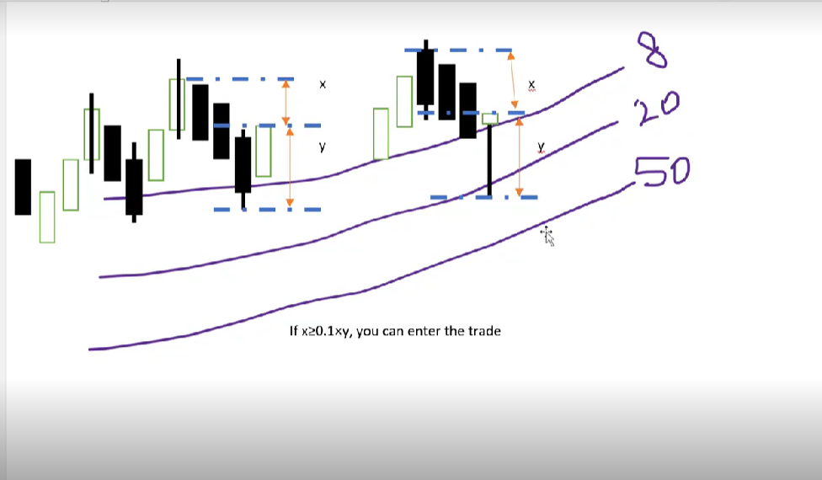

Generally,

X = the **“room to breath”** or the allowed space for the price to hit the current High or Low(next target) ( target here means close of the candle)

Y = the distance to the nearest low/high (the previous target)

O = the current price point at the close of candle 1 (closed)

Some notes: the current high or low can be the close of the candle instead of the Shadow

Rule #1: To enter a trade X Must be at Least 10% of Y.

Or more efficiently

X ≥ 0.1Y

Use **Fractals Indicator** to find SL/TP values:

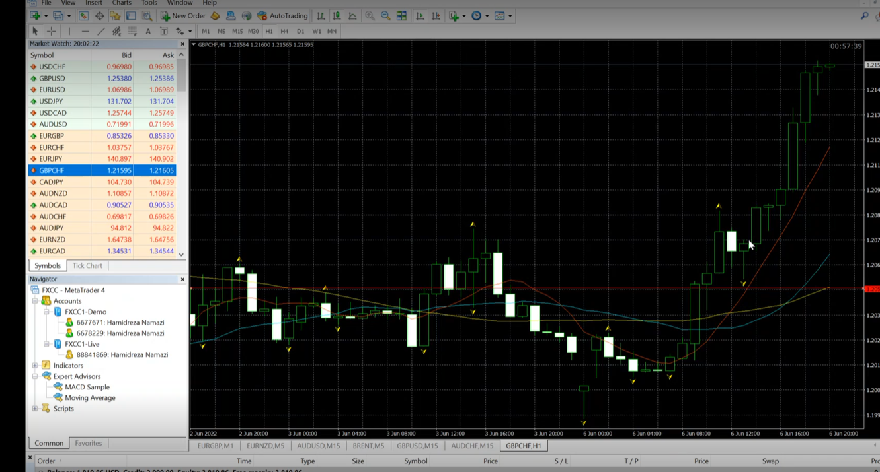

Rule #2: If X ≤ Y, your TP shall be Y from the O Point towards the direction of the trend

Please note that your Enter price may differ than the O point, because of Spread in that case check #3

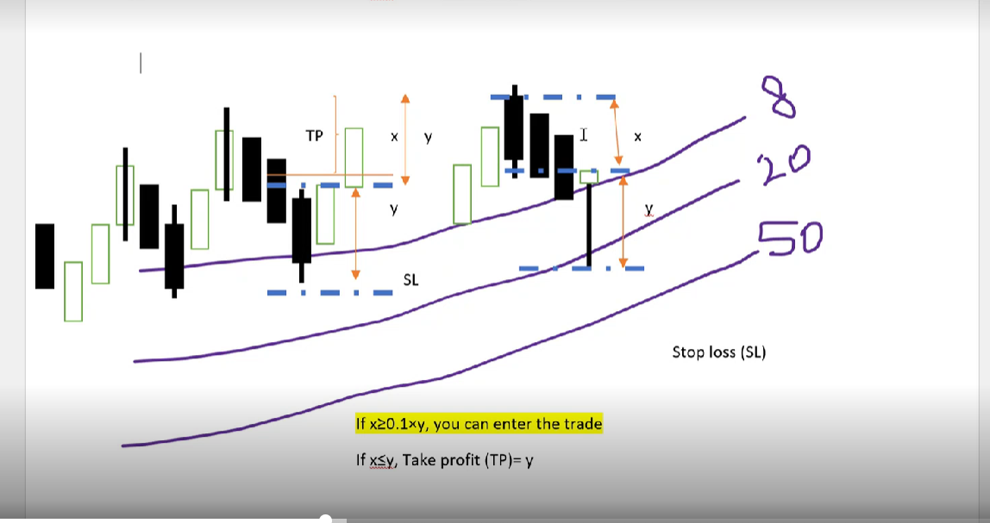

Rule #3 : Only take 1R:1R trades, and Only risk up to 2% of your account on a single trade, and have constant risk. (if you choose one,stay with it)

Use money management tool to count your Lot size for each market.

Rule #4: if X > Y, X will be your TP, but the maximum will be 2Ys

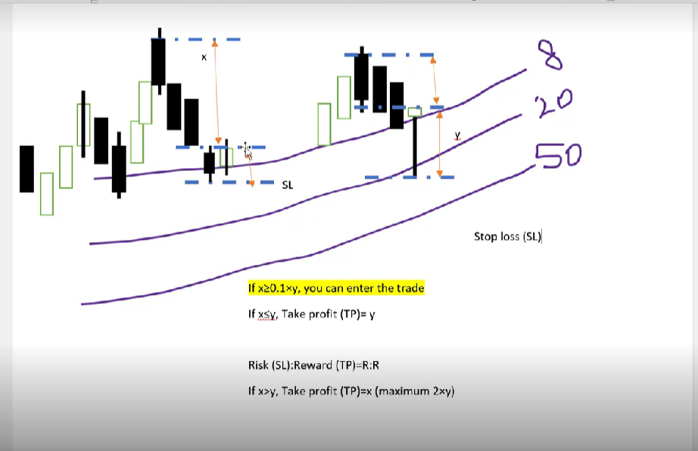

You can get RSI confirmation as well

In Uptrend, Below than 70

In Downtrend, More than 30